Practical - 1
Practical Title: Project Initiation, Requirement Analysis, Sitemap, Wireframe, and GitHub Setup

Problem Definition: Initiate the semester-long StudentHub portal by identifying the problem scope, user roles, key modules, navigation flow, and minimum 10 pages. Create a sitemap, low-fidelity wireframe, project folder structure, README file, and GitHub repository.

Theory

What is URL and parts of URL?
Answer: Write your A URL (Uniform Resource Locator) is a unique address used to locate and access resources on the internet. A URL is composed of multiple parts, each defining how and where a resource can be accessed. https://www.geeksforgeeks.org/computer-networks/components-of-a-url/

How does HTML file process in web browser?
Answer: A web browser processes an HTML file through a structured pipeline called the Critical Rendering Path (CRP), transforming raw code into the interactive visual page you see on your screen.
https://pavankumar-patruni.medium.com/the-process-behind-browser-loading-a-webpage-9fd80792ea94

3. How will page navigation flow managed among all HTML pages?
Answer: Page navigation flow across HTML files is managed using anchor tags (<a>) with relative or absolute file paths inside semantic <nav> menus, ensuring a consistent user journey.
youtube.com/watch?v=jHNIFMOW6es&t=1

4. How will GitHub commits be maintained after each practical?
Answer: After each practical, GitHub commits should be maintained by staging your completed work, writing a clear and descriptive commit message detailing what was done, and pushing the changes to your remote repository to secure a permanent history of your progress.
https://www.theserverside.com/video/Follow-these-git-commit-message-guidelines

Implementation/ Output/Result
Implementation of Wireframe
The wireframe of the StudentHub Portal was designed to represent the basic layout and structure of the website before development. It defines the placement of important elements such as the header, navigation menu, content sections, and footer.

Evidence of Work (Screenshots)

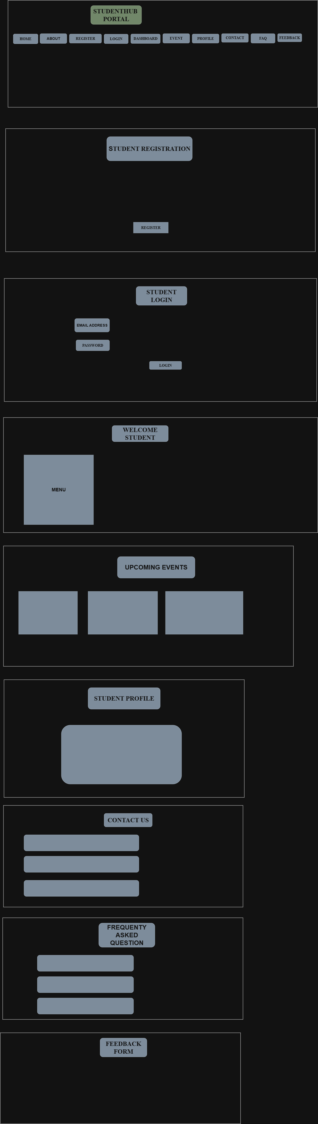
Description:
The StudentHub Portal is a web-based application designed to provide students with a centralized platform for accessing academic and campus-related services. The portal offers a simple and user-friendly interface with multiple sections that help students register, log in, view events, manage their profiles, contact the administration, access FAQs, and submit feedback.

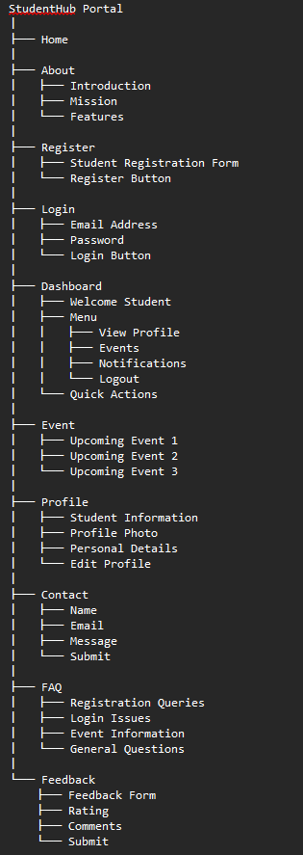

Description:
A sitemap is a hierarchical diagram or list that shows the structure and organization of a website. It illustrates how all the web pages are connected and helps developers, designers, and users understand the website's navigation.

GitHub Repository Link:

https://github.com/vatsal1950/basics-of-html.git

Learning Outcomes:
Students will be able to analyze requirements and prepare a structured project foundation before implementation.

Faculty Remarks:

